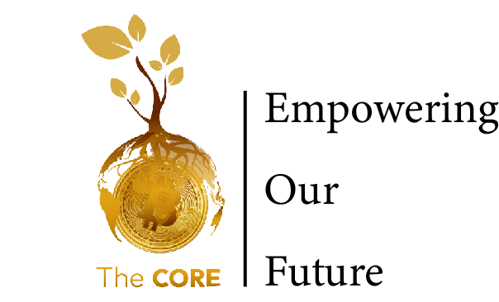

To even better enhance, we have found the following websites and YouTube videos to be very useful for educational purpose, You can pay a visit and learn from each,

**NOTE!** These Links are only for educational purposes, and we are not directing you to invest in anything from what you learn there. Every decision you make towards putting your money in Bitcoin, should be independent and after a clear understanding of what Bitcoin is all about.

if you get stuck, in anyway please feel free to reach out for Guidance  
  
**1. THE END OF MONEY AS WE ALL KNOW IT**This video will spotlight the history of money and its evolution from bartering to Bitcoin. It will provide insight into the challenges of traditional monetary systems and how Bitcoin is specifically designed to address and overcome these challenges.  
  
**Link:**

<https://youtu.be/BFKZoq2z39s?si=ffJfGQHM12niJL8F>

**2.THE SAYLOR SERIES**The Saylor Series, consisting of 17 episodes, will provide a comprehensive understanding of the concept of money, tracing its evolution from ancient times to the present day. Moreover, it will shed light on the significance of Bitcoin in the contemporary financial landscape  
  
**LIink:**[**https://youtu.be/4rvTppy1qLI?si=Zbk0B1p8edv3jeOn**](https://youtu.be/4rvTppy1qLI?si=Zbk0B1p8edv3jeOn) **3.SCHOOL OF BITCOIN**The School of Bitcoin is a user-friendly website that is compatible with all devices. It not only provides information about Bitcoin but also offers visual graphics to enhance your understanding of the topic. You can learn about Bitcoin at your own convenience and from the comfort of your home.

**Link:**

<https://schoolofbitcoin.com/>

To join our community, please click on the provided Linktree link. We also encourage everyone to have a Twitter account to stay updated on Bitcoin information. Bitcoin is a protocol that is constantly evolving, and most of the updates will be posted on Twitter and in our community groups.

**  
  
  
Linktree**

[**https://linktr.ee/thecore21m**](https://linktr.ee/thecore21m)

For any Inquiries or Guidance  
Reach out to us   
connect@thecore.africa  
+254 741 968 451

Regards.

Felix Mukungu  
Founder, The Core   
[felixongoma43@gmail.com](mailto:felixongoma43@gmail.com)  
+254 743 228 280